**Name:** Thanh Tam Vo

**StudentID:** 103487596

**COS10004 - Computer Systems – Assignment 1**

**Introduction**

This assignment 1 of the Unit COS10004 – Computer Systems aims to design a user interface of a music player by digital circuit via simulation application called Logisim

**Design Outline**

The circuit includes introduced components via Swinburne’s Lecture such as: button, logic gates (NOT, AND, OR, XOR, etc.), D Flip Flop, JK Flip Flop, HEX digit displays, etc.

To produce our product, the process is divided into 5 stages. The following section **Circuit Description** will elaborate on each stage. In general, our product has 5 buttons:

+ On/Off Indicator: Determine the status of our music player: On or Off

+ Volume Up: Increase the volume level of our music player

+ Volume Down: Decrease the volume level of our music player

+ Next Track: Go to the next track

+ Previous Track: Go to the previous track

Our music player’s status is determined by 2 LEDs

The volume level is displayed by the LED bar with 8 segments

Our track order is displayed by 2 components HEX digit display

The figure 1 on the next page is the interface of music player

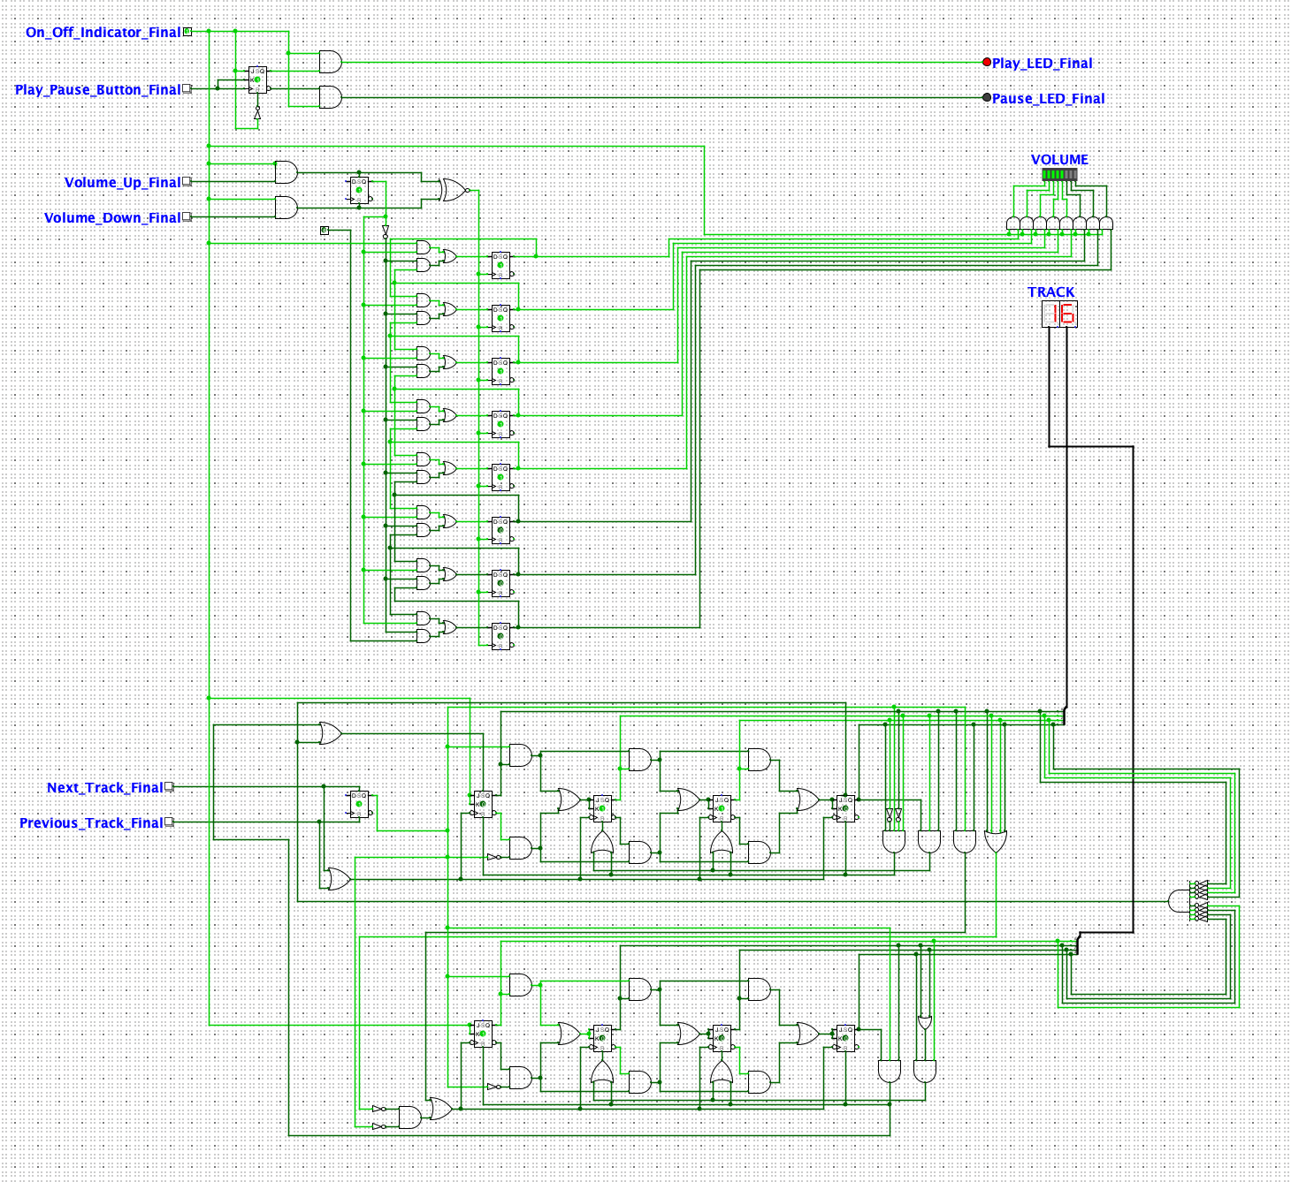

*Figure 1. Electronic circuit of the music player*

*(Screen captured from my Mac on October 22nd, 2022)*

**Circuit Description**

I will focus on each stage beginning with stage 1

**Stage 1A: PLAY/PAUSE implementation**

*Figure 2. Play/Pause Implementation*

*(Screen captured from my Mac on October 18th, 2022)*

Components List:

+ Play LED

+ Pause LED

+ Play Button

+ Pause Button

+ D-Flip Flop

**Description**

The circuit has 2 D-Flip Flop with rising edge, and the *Play Button* can be considered as a clock. The first D-Flip Flop, which is linked to the *Play Button*, indicates whether the *Play Button* have been pressed or not. If the *Play Button* is not pressed for the first time, the *Pause Button* will not affect the *Play LED* or the *Pause LED* (The timing diagram below will prove this statement)

*Figure 2.2. Timing Diagram for the Play/Pause Implementation*

*(Screen captured from my Mac on October 18th, 2022)*

**Stage 1B: Implement Pause-To-Play Transition**

*Figure 2.3. Pause-to-play Implementation*

*(Screen captured from my Mac on October 18th, 2022)*

Components List:

+ Play Button

+ Pause Button

+ Play LED

+ Pause LED

+ D Flip Flop

+ AND gates

**Description**

The circuit upon is upgraded comparing to the previous one in stage 1A. If the play button is not pressed for the first time, the Pause Button will not have any impact on two LEDs. In contrast, if the Play Button is pressed before, the Pause Button will have two functions:

+ If the music player is in PLAY state, pressing Pause Button will turn the music player to PAUSE state.

+ If the music player is in PAUSE state, pressing Pause Button will turn the music player to PLAY state.

The timing diagram below will show the implementation of stage 1B.

*Figure 2.4. Pause-to-play Implementation*

*(Screen captured from my Mac on October 20th, 2022)*

**Stage 2: Implement volume control and display**

The implementation is inspired by the 8-deep shift register, the Figure 1 below is the 4-deep shift register, which is the same as 8-deep shift register but with less D-Flip Flop.

*Figure 2.5 4-deep shift register*

*(Screen captured from my Mac on October 20th, 2022)*

**Volume control implementation**

*Figure 2.6. Volume controlling*

*(Screen captured from my Mac on October 21st, 2022)*

**Description**

9 D-Flip Flop are used in the circuit. Volume Up or Volume Down is determined by the first D-Flip Flop, and the signal is passed to the next 8 D-Flip Flop via an XNOR gate. I used the XNOR gate to ensure that the output from this gate is always 1 anytime I release the volume up (or volume down) button after pushing that button because the rest rising edge D-Flip Flop control volume levels.

**Stage 3: Implement track skipping**

**Synchronous Counter from 0 to 99**

The track skipping is inspired by the synchronous counter from 0 to 99. However, it should be modified to skip the 0’s stage, which means that the counter will count from 1 to 99. The figure 1 below is the implementation of counter counting 0-99 in electronic circuit.

*Figure 2.7. Synchronous counter counting from 0 to 99*

*(Screen captured from my Mac on Oct 22nd, 2022)*

**Implementation of Track Skipping**

*Figure 2.8. Track Skipping Implementation*

*(Screen captured from my Mac on Oct 22nd, 2022)*

**Stage 4: OFF stage implementation**

I decided to switch to the JK Flip Flop instead of D-Flip Flop because the JK Flip Flop has the toggle mode, which means that it will allow me to change from PLAY stage to PAUSE stage within a button (or vice versa). The system will always enter to the PAUSE stage whenever the ON/OFF indicator is activated, and all LEDs will turn off if the music player is in OFF mode. The figure 1 below indicate the idea of our implementation and a timing diagram proving that the music player always enters PAUSE stage whenever I power on the music player.

*Figure 2.9. On/Off implementation*

*(Screen captured from my Mac on October 22nd, 2022)*

*Figure 2.10. When the music player turns on, the system will be always at PAUSE stage*

*(Screen captured from my Mac on October 22nd, 2022)*

**Stage 5A: Storage for previous settings**

*Figure 2.11. Storage for previous setting*

*(Screen captured from my Mac on October 22nd, 2022)*

I decided to use a trick: if the On/Off indicator is at the Off Status, all buttons including: Volume Up, Volume Down, Next Track, and Previous Track will have no impact on our player.

**Stage 5B: Recalling previous settings**

When the On/Off indicator is at the Off Status, the Volume Display will also turn off. The Volume Player successfully turn off and recall the previous setting because it is linked directly to the On/Off Indicator. However, the Track Display will not turn it off when our player is in Off Status (but we cannot control the track when the player is in Off Status also, this is a plus), so I suppose this is a problem in my circuit.

**Unsolved Problem**

As I mentioned before in stage 5B, I do not consider this problem as unsolved. I prefer the word “*imperfect*”.

Moreover, I have not solved the track display problem: when we first time open the circuit, our track display looks like Figure 3 below

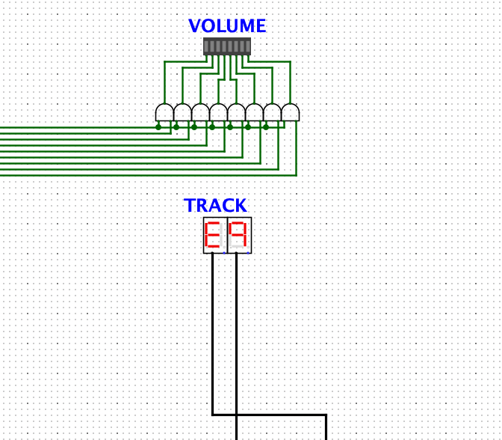

*Figure 3. Track display problem*

*(Screen captured from my Mac on October 22nd, 2022)*

I know this is inconvenient, but we can solve this problem by pressing the *Next Track Button.*

**Note**

The submission file Circuit.circ includes 5 stages and the final interface music player.